Pune District Education Association’s
Seth Govind Raghunath Sable College of Pharmacy, Saswad
&
Pune District Education Association’s
Seth Govind Raghunath Sable College of Pharmacy (Poly.), Saswad
Joint activity Participation
Activity Report
Title of the event: Seminar on “Computer knowledge and training session”
Name of activity: Faculty Development Programme
Venue: Seminar hall and practical Training in computer lab
Total number of participants = 24
Date and Day: 27/12/2023 Wednesday Time: 02:00 pm to 04:30pm
In today's fast-paced digital world, computer skills have become essential for almost every career. With the advent of new technologies and increasing reliance on digital platforms, employers seek candidates with strong computer skills. Whether you are a software developer, a graphic designer, a marketing professional, or a healthcare provider, having strong computer skills can help you to enhance your productivity, streamline your work processes, and boost your career prospects. In this view one day Faculty Development Programme for non-teaching staff on topic “Computer knowledge and training session” has been organized by the institute on 27th December 2023 at 02:00 pm.
Ms. Jyoti Chavan (Lecturer in Waghire College, Saswad) gave valuable guidance on “Computer knowledge and training session”. Non-teaching staff are greatly benefited and are sensitized from her views and guidelines.
The program ended with a vote of thanks by Ms. Smita Deshmukh. The activity was conducted under the guidance of Dr. Smita Pawar vice Principal and Dr. R.S. Chavan. Principal.

Mrs. S. M. Deshmukh Dr.Smita Pawar Dr. Rajashree Chavan
Co-ordinator Co-ordinator Principal

Photo Gallery (Faculty Development Program for non-teaching staff) 27/12 /2023
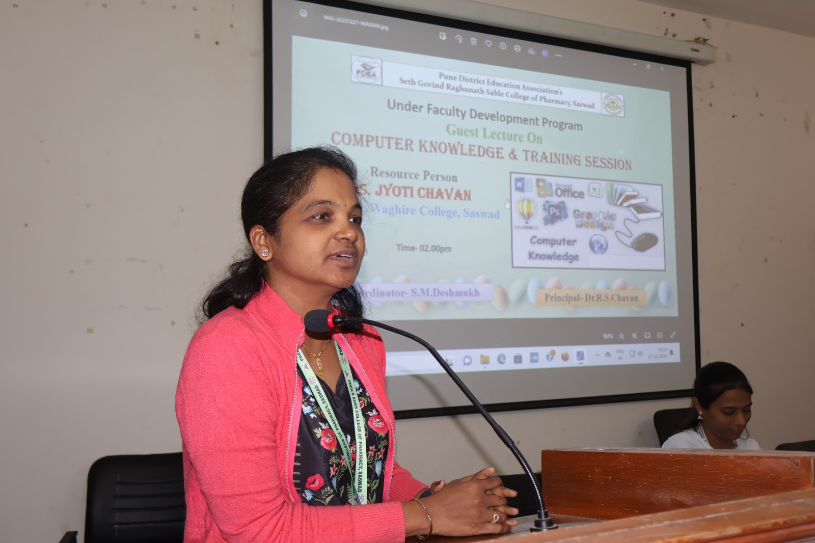
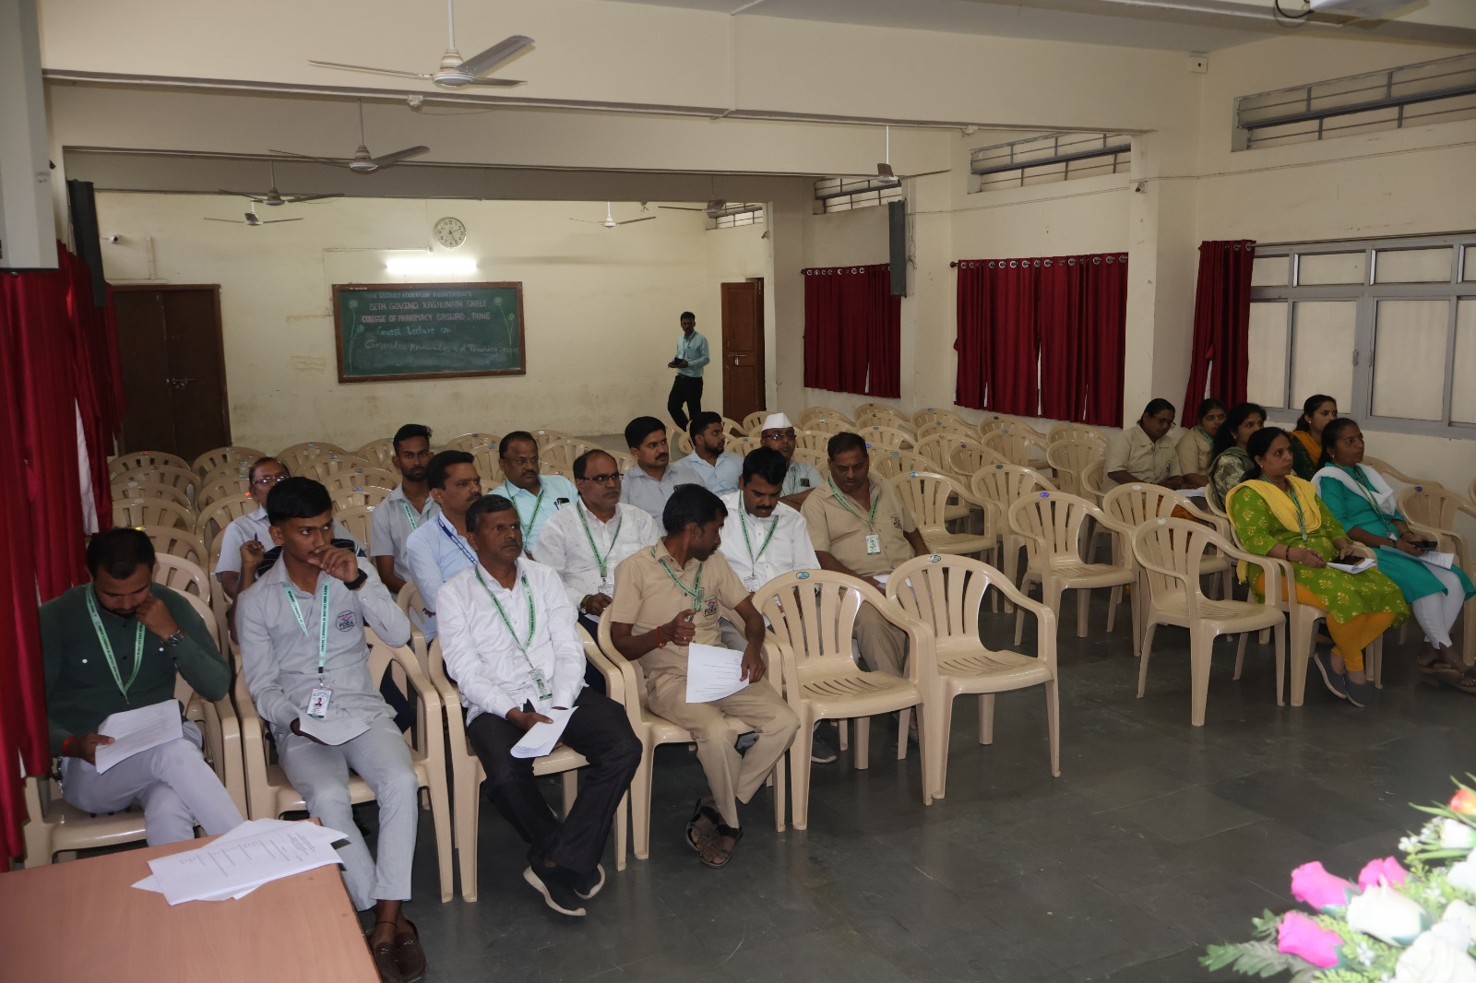

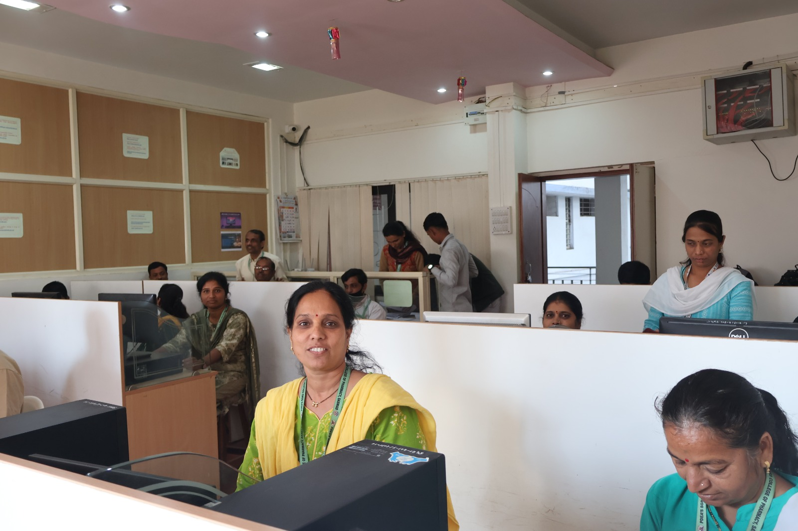
Photo Gallery (Faculty Development Program for non-teaching staff) 27/12 /2023

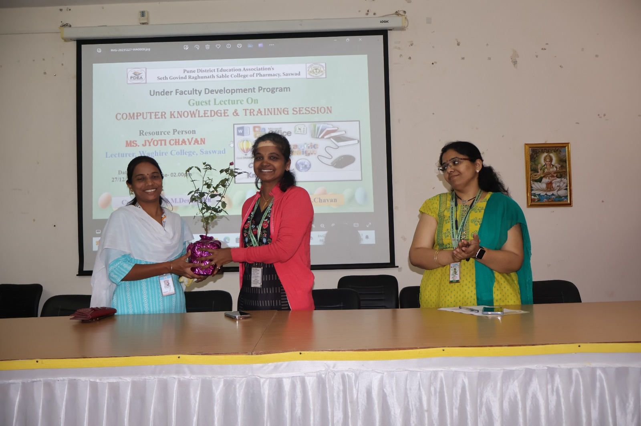
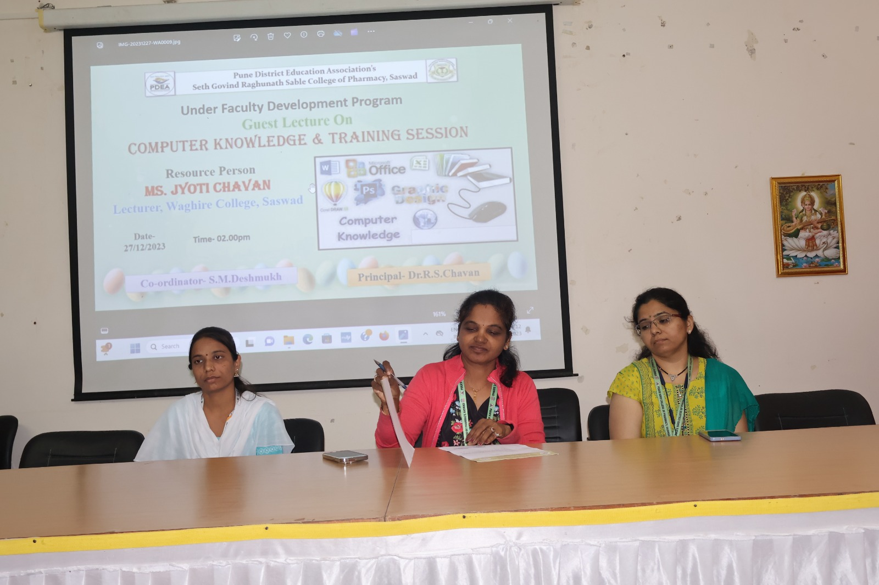
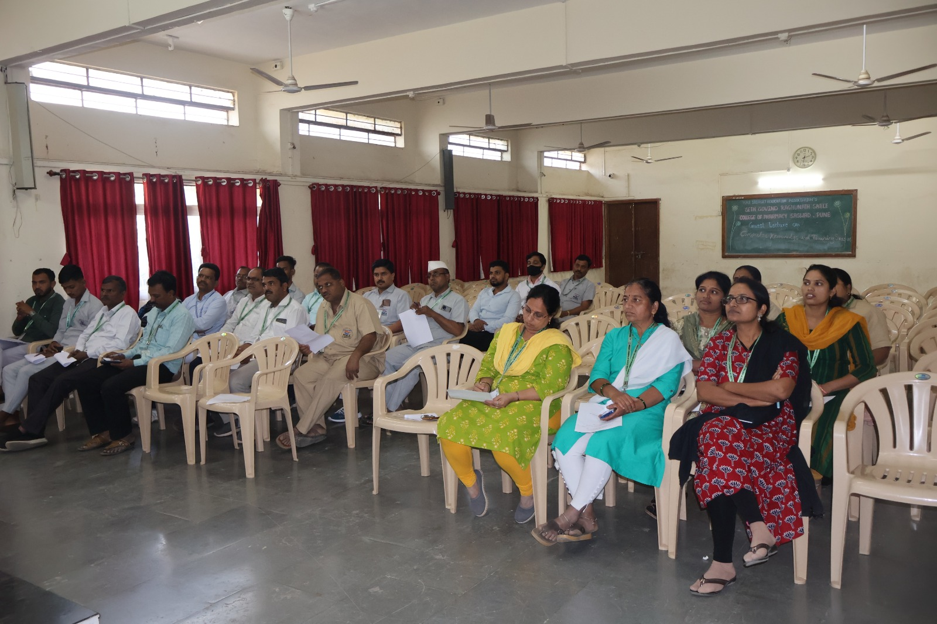

Dr.Rajashree Chavan
Principal

